Deploy index.html in docker container on jenkins master

-Shweta Raut

Step 1: configure jenkins master

Install java-17, Jenkins, docker, git

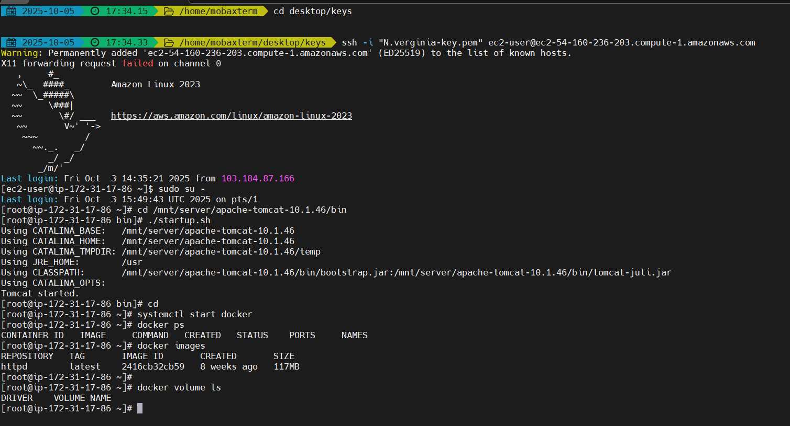

Step 2 : create git repo with 2 different branch 2025.Q1, 2025.Q2, 2025.Q3 and push index.html file in each repo

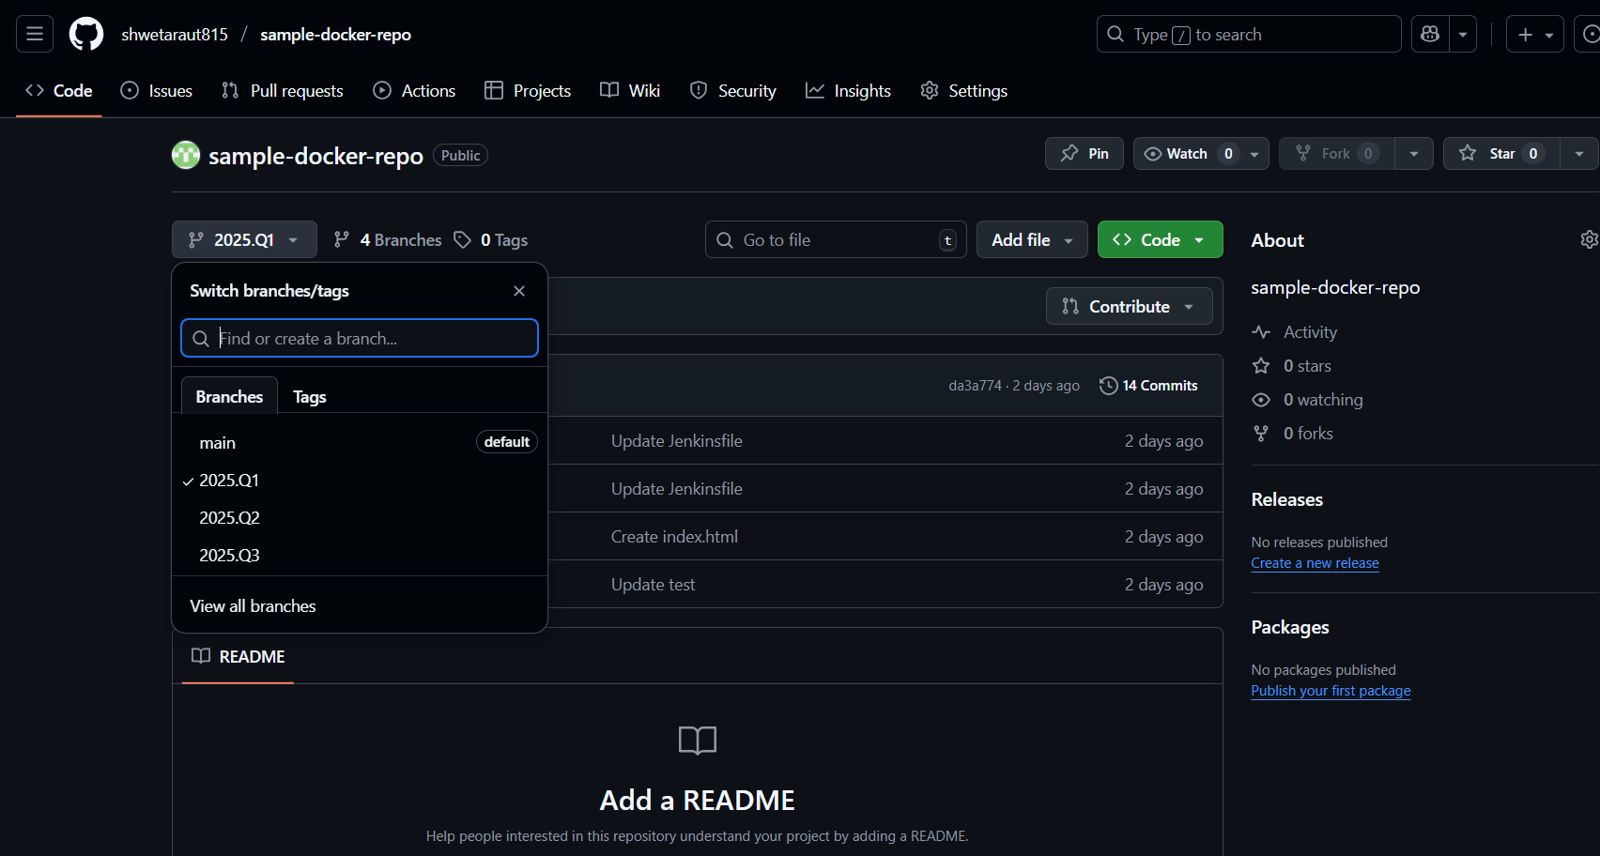

I use port for binding 80, 90, 8080

So my 8080 port is already in used for jenkins

So change the port of jenkins

File path : /mnt/server/apache-tomcat-10.1.46/conf/server.xml

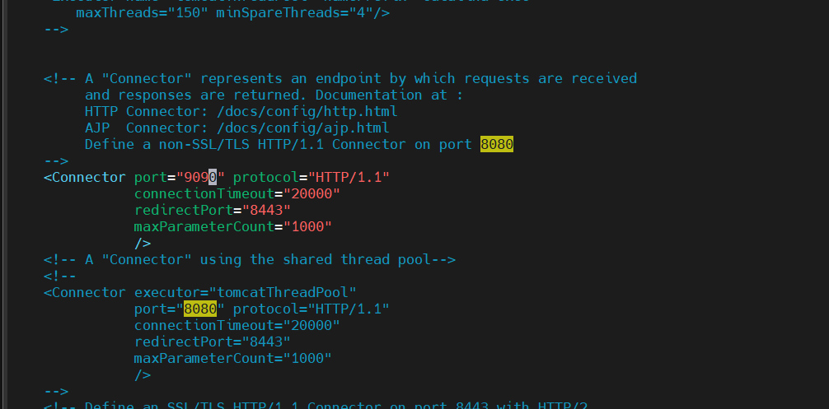

Step 3 : create jenkins declarative pipeline

pipeline {

agent {

label {

label "built-in"

customWorkspace "/root/2025-Q1"

}

}

stages {

stage("create container c1") {

steps {

sh "docker run -dp 80:80 --name c1 httpd"

}

}

stage("git checkout 2025-Q1") {

steps {

git branch: '2025.Q1', url: 'https://github.com/shwetaraut815/sample-docker-repo.git'

}

}

stage("copy index.html to container") {

steps {

sh "docker cp index.html c1:/usr/local/apache2/htdocs/"

sh "docker exec c1 chmod -R 755 /usr/local/apache2/htdocs/"

}

}

}

}

Step 4 : push Jenkisfile in github repo in each branch

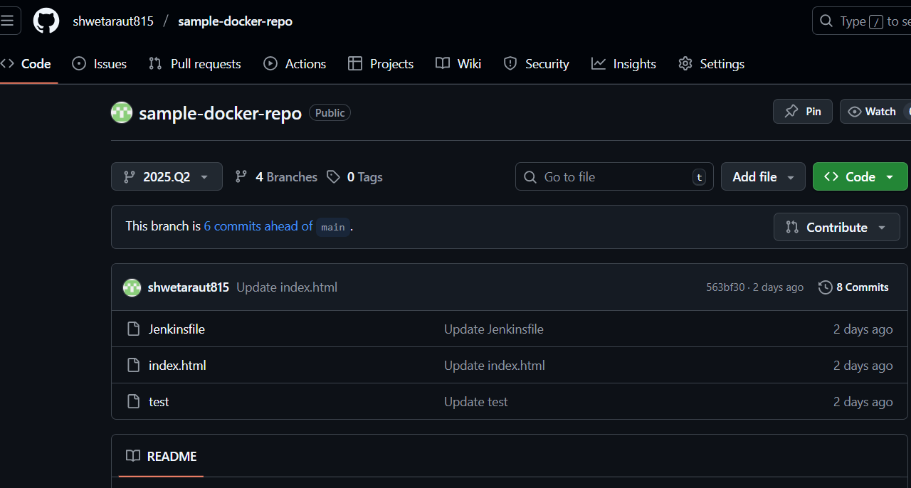

Step 5 : create multibranch pipeline job on jenkins dashboard

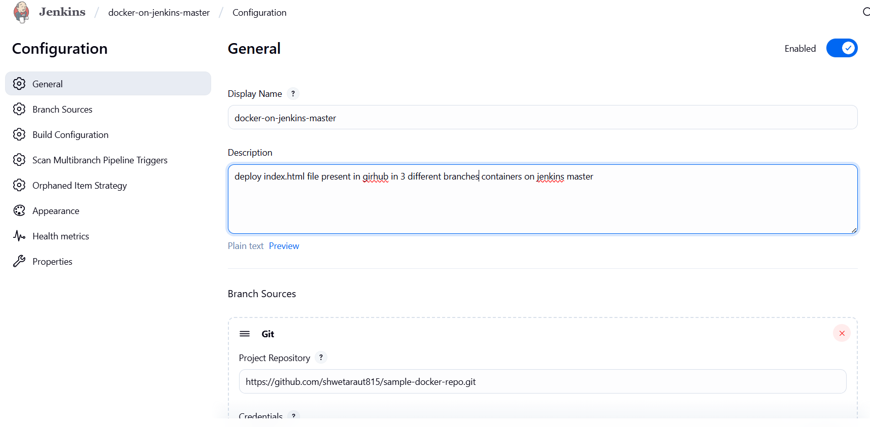

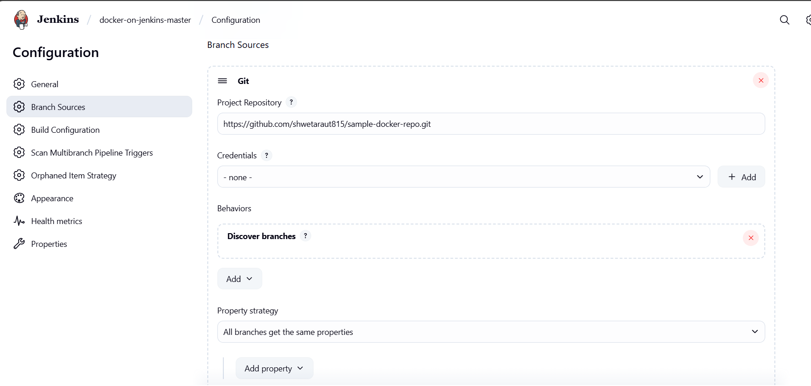

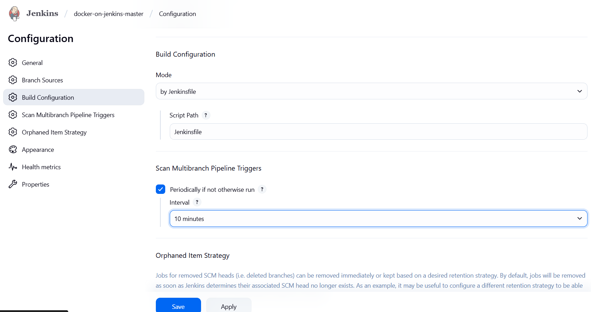

Scan multibranch pipeline

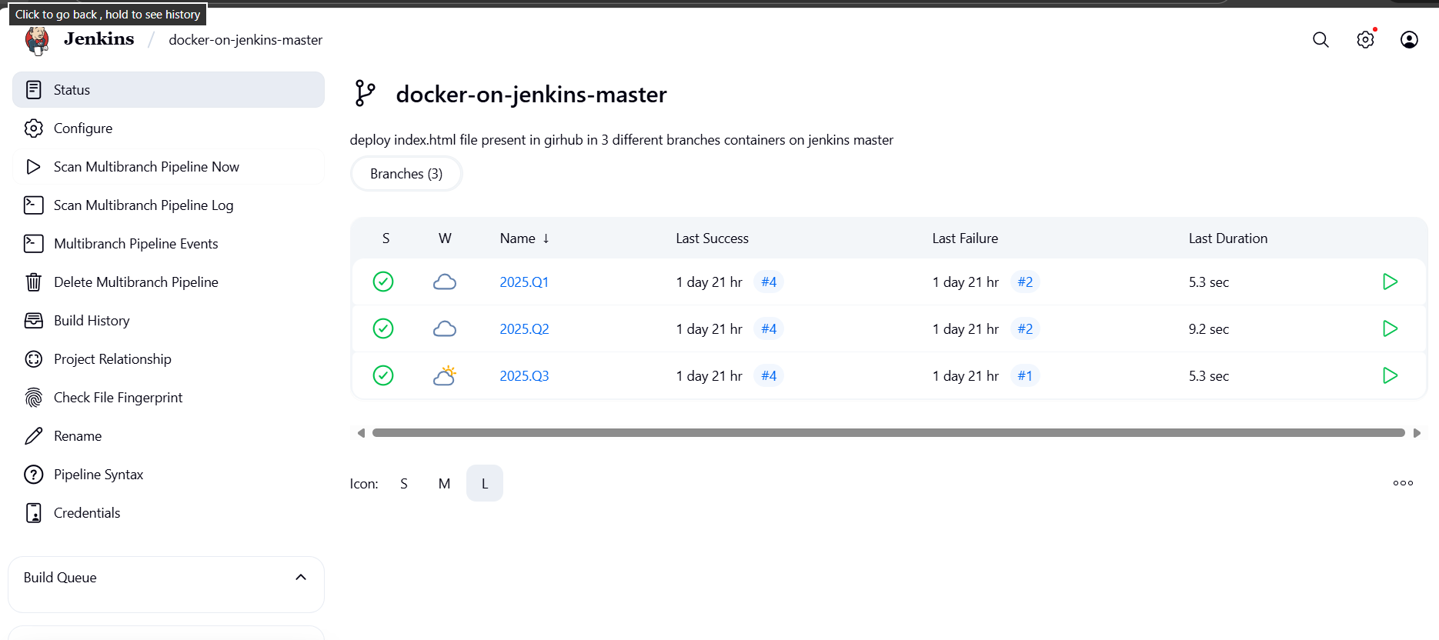

Here docker container is created

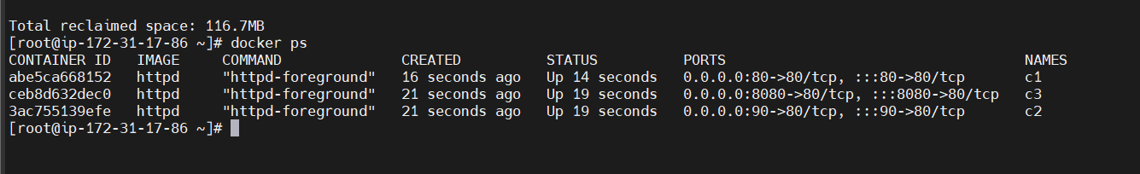

Port expose

C1 : 80

C2 : 90

C3 : 8080

Access index.html deployed in container on browser

